Issue Area Differences and Governing Networks

Matt Grossmann

Assistant Professor of Political Science

Michigan State University

303 S. Kedzie Hall

East Lansing, MI 48823

(517) 355-7655

matt@mattg.org

I thank Erik Jonasson, Matt Phelan, Haogen Yao, Martina Egerer, Erica Weiss, Michael Thom, Heta Mehta, Lindsay Vogelsberg, and Chris Heffner for reading literature and collecting data for this project. I thank participants in the Junior Faculty Research Workshop at Michigan State University for helpful comments and suggestions.

Abstract
The politics of public policy issue areas differ systematically in multiple ways, including the venues where policies are enacted, the frequency and type of policy development, the relative importance of different circumstantial factors in policy change, the composition of participants in policymaking, and the structure of governing networks. The differences across policy areas are not easily summarized by existing typologies or by universal theories of the policy process because each dimension by which the politics of policy areas differ is largely independent of the others. To understand these differences, I aggregate information from 120 books and 23 articles that review the history of American domestic public policy in 12 issue areas from 1945-2004. I use this record to assess when and where federal policymaking took place and who was responsible. The histories collectively uncover 717 notable policy enactments and credit 1,037 specific actors for their role in policy change. Based on the aggregate view from policy history, the politics of each issue area and the composition and structure of its governing network stand out in a few important but unrelated aspects. There is no evidence of a universally applicable theory of the policy process or of easily categorized issue types.

The federal government enacts important new policy each year in many different issue areas. Scholars seek to understand how the political system produces these public policies, but typically must choose particular issue areas as their focus of study. Though cognizant that the policy process likely differs across issue areas, scholars rarely consider these variations systematically. Are the politics of each issue area idiosyncratic or can we understand policymaking in many different issue areas as slight variations on an underlying universal policy process?
If there are unknown but systematic differences in policymaking across issue areas, the differences portend the limitations of all issue case selection decisions as well as any theory that claims to explain the policy process generically. Across issue areas, does national policymaking take place in the same venues with the same frequency? Is the relative importance of different political circumstances constant? Though scholars frequently investigate policy networks, the literature also lacks a clear sense of how networks differ based on their issue area. Is the composition of participants in policymaking and the structure of governing networks similar in different policy domains?
This paper investigates each of these questions, focusing on American federal policymaking in twelve broad policy issue areas since World War II: civil rights & liberties, criminal justice, education, energy, the environment, health, housing & development, labor & immigration, macroeconomics, science & technology, social welfare, and transportation. The argument is that the policy process is neither universal nor idiosyncratic; instead, the politics of each issue area and the composition and structure of its governing network stand out from the others in a few important aspects. These differences are not easily summarized by policy area typologies because the differences lie along many dimensions and most policy areas are typical on most of the dimensions and only outliers on a few of them. For example, one policy area might be characterized by high judicial policymaking, high path dependence, and low interest group influence but none of these aspects of its politics may be broadly associated across policy areas. A governing network in one policy area may be dominated by members of Congress, bipartisan in its links, and structurally similar to a core-periphery network but these features may not typically go together.
As a result, scholars are likely to focus on particular aspects of the policymaking process based on their case selection decisions, even though they may seek to generalize. Similarly, our theories of the policy process have not paid sufficient attention to variations across issue areas; assuming differences based on theoretical categorizations of types of political conflicts will not help. The relevant circumstances and actors change with the issue territory, as do the relationships among actors and the types of policy activity. Rather than select between the alternatives of assuming universality in the policy process or creating unique theories of policymaking in each issue area, scholars can systematically understand their usual variations.
This paper addresses these variations using historical studies in each of twelve domestic policy areas. First, it compares universal theories of the policy process, issue-specific alternatives, and attempts to categorize issue area types. Second, it critiques the concept of issue networks, articulating an alternative view of how to analyze governing networks in each issue area. Third, it explains the method, which relies on an original content analysis of 120 books and 23 articles that review American national policy history. Fourth, it reviews the history of policy enactments across all branches of government in each issue area and the explanations for policy change found in the secondary sources, including their description of the policy process and relevant circumstances. Fifth, it analyzes the governing networks associated with each issue area, relying on information about the actors credited with policy enactments by policy historians. Finally, it attempts to make sense of how the policy process differs across issue areas and provides descriptions of the unique features of each issue area to guide future scholarship. The agenda to develop theories of the policy process can only move forward by acknowledging and analyzing issue area differences.

Issue Area Politics and the Policy Process
Most theories of the policy process either assume universality or largely ignore likely differences across policy areas. In the classic textbook version of the policy process, policymaking occurs in stages: policymakers identify problems, set their agenda, formulate alternatives, adopt a policy, implement it, and then evaluate it. Contemporary theories of the policy process typically collapse the stages or argue that the order is flexible, but focus primarily on the agenda setting stage. Punctuated-equilibrium accounts (Baumgartner and Jones 1993), for example, argue that limited policymaker attention means that policy change is unlikely absent a large increase in consideration of a problem. Other models emphasize the multiple, largely independent, streams of problem definition, politics, and policy development (Kingdon 2003). In this view, policy alternatives often come before a problem reaches the top of the agenda but are only adopted when the time is right. The advocacy coalition framework instead focuses on the ideas and beliefs developed by interest group and government proponents of policy change (Sabatier and Jenkins-Smith 1993). These theories focus on the mechanisms by which actors bring issues to the forefront of public and elite debate, but they are all applied flexibly to many different types of actors in many issue domains.
These theories of the policy process, however, are not evaluated in most subject-specific literature on U.S. policy change. Literature on civil rights policy, for example, focuses on protest movements (Stetson 1997) and presidential leadership (Shull 1999). Literature on education policy emphasizes the appropriations process (Spring 1993) and bureaucratic politics (Cross 2003). Environmental policy histories tend to compare federal policy to an ideal type where technocrats utilize scientific research results to decide optimal policy (Portney and Stavens 2000; Graham 2000). Unlike the policy process literature, therefore, most of these accounts emphasize that a few important actors and circumstances made policy change possible. They focus on the history of policy adoptions, pointing toward individuals and organizations that helped to set the agenda only when their actions are deemed critical to successful policy change. Nevertheless, like the policy process literature, subject-specific policy histories generally reject the textbook stages model. They recognize that policy change can come from administrative agency rulemaking, court decisions, and presidential actions, as well as legislation; they also point to instances in which policy change preceded comprehensive problem identification or a full consideration of alternatives.
Not all theories assume that the policy process will be either idiosyncratic or universal across issue areas. Theories of policy area differences tend to focus on one or two dimensions of variation associated with clear types. Theodore Lowi (1964) divides policy issues into three types: redistributive, distributive, and regulatory. The politics of each type are defined by the likely interest group competition associated with what is at stake in each debate. This categorization has been difficult for scholars to follow, since most policy areas have elements of all three types of policy tools (Smith 2002). Applying it to the twelve issue areas analyzed here might involve categorizing criminal justice and energy as regulatory, transportation and health as distributive, and social welfare and housing & development as redistributive but others would be harder to place in the typology. The idea is that scholars should expect to find differences in the politics of each issue area based on the kind of policy under debate and who has something to gain or lose from policy action. Similarly, James Q. Wilson (1980) argues that policy issues can be divided into types based on whether the costs and benefits of policy action in the area are concentrated or dispersed: interest group politics where both are narrow, entrepreneurial politics where only costs are concentrated, client politics where only benefits are concentrated, and majoritarian politics where both are broad. Based on this categorization, scholars might place energy in the interest group politics box, housing & development and labor & immigration in the client politics category, the environment and criminal justice in the entrepreneurial box, and health and macroeconomics in the majoritarian category.
These classic typologies have not proved especially fruitful in understanding policy area differences, but new typologies have proliferated (Smith 2002). A new classification by Ira Katznelson and John S. Lapinski (2006) divides domestic affairs into planning and resources (including the environment), political economy (including labor and macroeconomics) and social policy (including education) but places civil rights in a separate category from domestic affairs. Many of the newer typologies, however, are prescriptive and meant to analyze effectiveness in achieving policy goals, rather than designed to understand differences in the policy process (Vedung 2003).
Kevin Smith (2002, 381) advocates a move from typologies to taxonomies, classifying items “on the basis of empirically observable and measurable characteristics.” This requires identifying characteristics of policies, measuring them, and looking at how they relate to one another. This paper generally takes this approach, but does not assume that it will uncover clean breaks between policy area types. The project seeks to move beyond two fundamental problems of policy typologies. First, they assume that differences in the politics of policy areas can be distilled into only a few important dimensions. Second, they assume that most policy areas will fall in a clear zone along these dimensions. There is no a priori reason why either assumption is likely to be true. I assume instead that important differences across policy areas may not be associated and each policy area may stand out on only a few important dimensions.

Issue Networks and the Policy Process
If differences across policy areas produce distinct politics, scholars should observe different kinds of networks emerging in different policy areas. The concept of “issue networks” has become the baseline perspective for observing communities of actors surrounding policymaking in each domain. In the classic formulation, Heclo (1978) argues that discussions of policy within each issue area take place in networks of experts that come from both inside and outside of government. These individuals are associated with myriad institutions but they gain their place in the network from their reputations for issue knowledge, rather than their institutional role. Heclo saw this as a substantial transformation from an earlier period in which policymaking occurred within institutions and policies were debated among a few prominent stakeholders. Some have drawn on this argument to claim that policymaking went from a period of iron triangles to a period dominated by issue networks (see Berry 1989). Iron triangles were ideal types of policymaking involving a set of client interest groups, an executive agency, and relevant congressional committees. Issue areas like energy, housing & development, labor & immigration, science & technology, and transportation all still have these institutions and are sometimes considered candidates for networks that resemble iron triangles.
Even though Heclo referred to networks, his analysis was not explicitly tied to any specific conception of network structure used in social network analysis. Other scholars, however, have sought to use network techniques to understand relationships among policymakers within policy areas. Heinz et al. (1993), for example, use surveys to find out who interest group leaders and lobbyists view as their allies and adversaries in four policy domains. They analyze the coalitions in each area, as seen by participants. They investigate the shape and structure of interest group coalitions in these four policy areas and find that most policy conflicts feature a “hollow core,” with no one serving as a central player, arbitrating conflict. In some areas, government agencies are caught in the middle between opposing sides; in others, disconnected issue specialists are linked only to those who work on similar topics and share views.
David Marsh and R. A. W. Rhodes (2004) distinguish between issue networks and policy communities, arguing that issue networks are larger and broader with less frequent contacts and more disagreement. They provide a list of characteristics of interest for studying both types of policy networks, but do not predict when issue areas will be associated with vibrant issue networks or small policy communities. Though some form of issue network has been found in a wide variety of areas, there is no scholarly consensus on the variation in issue networks across issue areas or whether network structures vary systematically by issue area characteristics (Marsh and Rhodes 2004).
Political scientists expect some issue areas to be more polarized by partisanship than others, and some areas to be more dominated by one of the two parties. Issues might produce more polarized issue networks if they are of high public salience, such as education, than if they are low salience issues like science & technology. One party might dominate an issue network if they “own” the issue in the minds of the public, meaning the public trusts the party more on that issue than the other party (Petrocik 1996). For example, Republicans are said to own criminal justice and macroeconomics, whereas Democrats might own education and the environment.
These ideas about issue network composition and structure are not necessarily meant to be universal. Most studies of issue networks select a policy area of focus based on interest and rarely collect data across many areas to look for differences. Research based on the advocacy coalition framework (Sabatier and Jenkins-Smith 1993) has used network analysis extensively, but has been concentrated in studies of the environment (see Weible, Sabatier, and McQueen 2009). Scholars lack theories of how issue networks differ across issue areas, likely because they rarely encounter comparative network data.
This paper explicitly looks for differences across issue networks, again expecting issue area differences to be multidimensional and not to allow categorization into separable types. In particular, the composition of networks (such as the partisan or institutional affiliations of its members) may vary independently of its structure. The networks analyzed here, however, are not made up of all of the participants in policy communities or everyone seeking to influence public policy. Instead, the policy histories allow analysis of what I call “Governing Networks” made up of the people credited with policy enactments in each issue area. All of the issue areas analyzed here have a network of actors jointly responsible for policy development. Using Governing Networks enables an assessment of only those people who have a role in policy development in each area, rather than everyone who has opinions about a policy area. This avoids the problem of borderless issue networks, but not by assuming that policy communities will be restricted in size or composition. I expect that none of these Governing Networks are likely to resemble ideal types like iron triangles, but they will differ in important compositional and structural characteristics that constitute key aspects of their political processes.

Compiling Policy Area Histories
I use secondary sources of policy history to understand differences in policymaking and Governing Networks across issue areas. Policy specialists often review extensive case evidence on the political process surrounding policymaking in broad issue areas, attempting both to catalog the important output of the political process and to explain how, when, and why public policy changes. These authors identify important policy enactments in all branches of government and produce in-depth narrative accounts of policy development. David Mayhew used policy histories to produce his list of landmark laws; he defended them as more conscious of the real effects of public policy and less swept up by hype and spin from political leaders than the contemporary judgments used by other scholars to understand policy history (Mayhew 2005, 245-252). Since Mayhew completed his analysis of this literature in 1990, there has been an explosion of scholarly output on policy area history. By my count, more than 80% of the literature covering policy history has been published since that time. Yet scholars have not systematically returned to this vast trove of information.
In what follows, I compile information from 143 books and articles that review at least one decade of policy history since 1945. The sources cover the history of one of twelve domestic policy issue areas: civil rights & liberties, criminal justice, education, energy, the environment, health, housing & community development, labor & immigration, science & technology, social welfare, macroeconomics, and transportation. This excludes defense, trade, and foreign affairs, but covers nearly the entire domestic policy spectrum. The policy histories collectively uncover 717 notable policy enactments in these issue areas, primarily laws passed by Congress but also executive orders, agency rules, and court decisions.
I compiled published accounts of federal policy change in the twelve broad policy areas using bibliographic and online searches. For each policy area, I used keywords from the topic lists and subcategories available from the Policy Agendas Project (PAP) at policyagendas.org. The PAP is funded by the National Science Foundation and its categories have been used in at least 34 published articles. I searched multiple book catalogs and article databases for every subtopic mentioned in the PAP description of each policy area. To find additional sources, I then used bibliographies from these initial sources as well as literature reviews. To locate the 143 sources used here, I reviewed more than 500 books and articles. Most of the original sources that I located did not identify the most important enactments or review the political process surrounding them, even though their titles or descriptions suggested that they might. Instead, many focused on advocating policies or explaining the content of current policy; these were eliminated. Sources that focused on a single enactment or covered fewer than 10 years of policymaking were also excluded. Sources that analyzed the politics of the policy process from a single theoretical orientation without a broad narrative review of policy history were also eliminated. Books were far more likely than articles to make the cut. My analysis expands Mayhew’s (2005) source list by more than 140%.
All of the sources are listed in the appendix. The civil rights & liberties policy area, corresponding to category 2 from the PAP, includes issues related to discrimination, voting rights, speech, and privacy. The criminal justice area corresponds to category 12 from the PAP and includes policies related to crime, drugs, weapons, courts, and prisons. Education policy, category 6 from the PAP, includes all levels and types of education. The energy issue area, category 7, includes all types of energy production. The environment issue area corresponds to category 8 and includes air and water pollution, waste management, and conservation. Health policy, category 3, includes issues related to health insurance, the medical industry, and health benefits. Housing & community development, corresponding to PAP category 14, includes housing programs, the mortgage market, and aid directed toward cities and rural areas. Labor & immigration, category 5, covers employment law and wages as well as immigrant and refugee issues. The macroeconomics area, category 1, includes all types of tax changes and budget reforms. Science & technology, corresponding to category 17, includes policies related to space, media regulation, the computer industry, and research. Social welfare, category 13, includes anti-poverty programs, social services, and assistance to the elderly and the disabled. The transportation area is category 10 and includes policies related to highways, airports, railroads, boating, and trucking. I obtained a larger number of resources for some areas than others, primarily because a substantial scholarly community has developed around the politics of some policy areas (such as civil rights & liberties) but not others (such as transportation). Analyzing additional volumes covering the same policy area, however, reached a point of diminishing returns. In the policy areas where I located a large number of resources, the first five resources covered most of the significant policy enactments.
The next step was reading each text and identifying significant policy enactments. I primarily used six research assistants, training them to identify policy changes. Other assistants coded individual books. I followed Mayhew’s protocols but tracked enacted presidential directives, administrative agency actions, and court rulings along with legislation identified by each author as significant. I include policy enactments when any author indicated that the change was important and attempted to explain how or why it occurred. As a reliability check, two assistants assessed two of the same books and identified the same list of significant enactments in both cases. For each enactment, I coded whether it was an act of Congress, the President, an administrative agency or department, or a court. When comparing two different coders of the same volume, there was universal agreement on this indicator.
I coded all policy histories for the circumstances and factors that each author judged significant in each policy enactment. The typical explanation refers to a few circumstances that led to a policy change; I catalogued every factor that these authors included in their explanations. The authors appear to select their explanatory variables based on the plausibly relevant circumstances surrounding each policy enactment with attention to the factors that seemed different in successes than failures, though they rarely systematize their selection of causal factors across cases.
To capture their explanations, I had coders ask themselves more than 70 questions about each author’s explanation of each change from a codebook. I used a formal spreadsheet-based content analysis to record each author’s explanation for every significant change in public policy that they analyzed. The result is a database of which factors were judged important by each author. Coders of the same volume reached agreement on more than 95% of all codes. Comparisons of different author explanations for the same enactment showed that some authors recorded more explanatory factors than others. The 12 authors that analyzed the Civil Rights Act of 1964, however, obtained 92% agreement in analyzing the circumstances that led to its passage. In the results below, I aggregate explanations across all authors, considering a factor relevant when any source considered it part of the explanation for an enactment.
Most of these authors rely on their own qualitative research strategies to identify significant actors and circumstances. For example, the books that I use quote first-hand interviews, media reports, reviews by government agencies, and secondary sources. I rely on the judgments of experts in each policy area, who have already searched the most relevant available evidence, rather than impose one standard of evidence across all cases and independently conduct my own analysis that is less sensitive to the context of each policy debate. A similar method was successfully used by Eric Schickler (2001) to assess theories of changes in Congressional rules.
In addition to coding the sources for the circumstantial factors associated with policy enactments, I also recorded every individual and organization that was credited with bringing about policy change. For each policy enactment mentioned by each author, I catalogued all mentions of credited actors (proponents of policy change that were seen as partially responsible for the enactment). I then combined explanations for the same policy enactments, aggregating the actors that were associated with policy enactments across all authors. The result is a database of which actors were judged important for, or partially credited with, each policy enactment. Coders of the same volume reached agreement on more than 95% of actors mentioned as responsible for each enactment. Comparisons of different author explanations for the same event showed that some credited more actors than others, though they did not explicitly discount actors that others considered important.
This method is related to the analysis performed by John Kingdon (2003). He reports counts of which actors were most influential in driving changes in transportation and health policy, but his analysis relies on his own first-hand interviews. I aggregate across all explanations offered by many different authors. Authors rarely go through every potential actor that might have been involved in each policy change, eliminating all those considered irrelevant. The typical explanation credits a few actors that were partially responsible for a policy enactment. For example, the authors do not list every member of Congress that supported a bill that made it into law; they list those that seemed most responsible for its success.
Combined, the policy histories identify 1,037 actors that they partially credit with at least one policy enactment. I categorized them based on which of the three branches of government they came from, if any. I also counted the number of members of Congress, interest groups, and government organizations credited with policy enactments in each issue area. Interest groups include corporations, trade associations, advocacy groups, or any other private sector organization.
I use affiliation networks to understand the structure of Governing Networks in each issue area. These networks include all of the actors that were partially credited with a policy enactment in each issue area, with undirected ties based on the participants that were jointly credited with the same policy enactments. This does not necessarily indicate that the actors actively worked together, but that they were both on the winning side of a significant policy enactment and that a policy historian thought they each deserved some credit. The affiliation network ties are valued as integer counts of the number of shared policy enactments between every pair of actors.
Several robustness checks confirmed that using qualitative accounts of policy history produces reliable indicators. First, controlling for the number of actors they mention, different authors credit a similar distribution of actor types and often the same list of credited actors for each enactment. They also produce substantially similar lists of relevant circumstantial factors in each enactment. Second, authors covering policy enactments outside of their area of focus (such as health policy historians explaining the political process behind general tax laws) also reached most of the same conclusions about who was involved and what circumstances were relevant as specialist historians. Third, there were no consistent differences in the types of actors credited and few differences in relevant circumstantial factors based on whether the authors used interviews, quantitative data, or archival research, whether the authors came from political science, policy, sociology, economics, history, or other departments, or how long after the events took place the sources were written. There were idiosyncratic differences across authors, but they did not produce the systematic differences in explanations across policy areas.

Policy Enactments Across Issue Areas
Policy can be enacted in any branch of government, though not with equal likelihood. Figure 1 depicts the percentage of policy enactments in each issue area that occurred in each venue, separating laws passed by Congress from executive orders by the president, administrative agency rules, and court decisions. As a reminder, the dataset only includes enactments that were considered policy decisions by policy historians in each issue area, rather than every government action. Agency rules or court cases are quite numerous, for example, but rarely amount to a significant policy change in the eyes of policy historians. Unsurprisingly, the results indicate that Congress dominates policymaking in most issue areas. Nevertheless, a few issue areas stand out for the extent to which policy enactments occurred in other branches of government. In civil rights & liberties, criminal justice, and labor & immigration, policymaking occurs disproportionately in the judiciary. Enactments in the energy and science & technology domains are more likely to come from administrative agencies than in other issue areas. Direct policymaking by the President accounts for a share of policymaking in all areas, but is quite common in macroeconomics and education.
[Insert Figure 1 Here]
Policymaking in each issue area also differs dramatically in its frequency: some issue areas are associated with many more policy enactments. In the current literature, this is usually understood as a consequence of agenda setting: some issues are more frequently on the minds of policymakers. Figure 2 compares the total policy enactments in each issue area from 1945-2004 with the total number of congressional hearings in each area over the same period, the PAP’s preferred measure of the prominence of each issue area on the policy agenda. The correlation between the two measures is .45, meaning that areas high on the agenda also involve more policymaking. Nevertheless, some issue areas like transportation are commonly on the agenda but infrequently associated with policy enactments. There is significant variation in the frequency of policymaking across issue areas, only some of which appears to follow from agenda setting.
[Insert Figure 2 Here]

Reported Circumstances Responsible for Policy Enactments
Issue areas also differ substantially in the circumstantial factors that are reportedly associated with policy enactments. One important source of differences is the extent to which policymaking is episodic or path dependent. Punctuated-equilibrium accounts of the policy process (Baumgartner and Jones 1993) imply that most significant policy change is episodic, occurring at the height of political interest in an issue area; other incremental policy enactments are thought to be less important. In contrast, historical approaches to policy change (Pierson 2004) argue that most significant policymaking is developmental; it relies on a path dependent process where early decisions constrain later decisions. Figure 3 provides measures of the role of path dependent and episodic factors in driving policy development in each area. It compares the percentage of policy enactments where policy historians offered explanations involving path dependence with the percentage of enactments where the historians pointed to particular focusing events as driving policymaking. Explanations involving path dependence included that the enactment was an extension of an earlier policy, that an earlier choice made the enactment more likely (such as relying on a funding formula created elsewhere), or that an earlier choice eliminated a potential alternative policy. Explanations involving events pointed to the effects of war, economic downturn, a government financial problem, a focusing event like a school shooting, or a case highlighting problems in a previous policy (such as fraud allegations).
[Insert Figure 3 Here]
The results show that policy enactments in education, housing & development, and labor & immigration are most likely to involve path dependence whereas enactments in energy and macroeconomics are more likely to be associated with focusing events. Using a t-test for differences in proportions between enactments in each issue area and all others, criminal justice, education, health, and social welfare are significantly less episodic and energy, the environment, labor & immigration, and macroeconomics are significantly more episodic than other areas. Criminal justice and health are significantly less path dependent whereas housing and labor & immigration are significantly more path dependent than other areas. There is also a relationship between these explanations and the prominence of an issue area on the congressional agenda. The more episodic a policy area, the more likely it will be associated with more congressional hearings. The correlation between the difference between the percentage of enactments that were episodic and those that were path dependent is correlated with the number of congressional hearings in each issue area at .44. This suggests that analyzing the policy agenda helps track episodic policy areas but may miss significant enactments in areas with more path dependence. To clarify, path dependent policy enactments are not necessarily less important. For example, the No Child Left Behind act was affected by the history of the Elementary and Secondary Education Act (it is formally an extension of the act), but it is still considered among the most significant recent policy enactments.
In addition to providing insight on the type of policy development common in each issue area, the policy histories point to different circumstances associated with policy change. Table 1 reports the percentage of policy enactments in each issue area associated with six categories of circumstantial causal factors, as judged by at least one policy historian. Explanations involving media coverage pointed to generalized attention or specific articles. In the public opinion category, I include general references to public opinion as well as references to issues raised in an election campaign or in a public protest. Explanations involving interest groups include those that point to lobbying or pressure from non-governmental organizations, corporations or business interests, professional associations, or unions. Those involving international factors include references to foreign examples, international pressure, or international agreements. Explanations involving state or local factors include references to state or local actions that preceded federal action, reports from state or local officials, or modeling of federal policy on state plans. For explanations involving research, I included references to data or research findings, think tank or academic involvement, or government or private research reports. To determine statistical significance, I use a t-test for differences in proportions between enactments in each issue area and all other areas.
[Insert Table 1 Here]
Media coverage was most commonly associated with policymaking in the areas of social welfare and transportation. Public opinion was a commonly reported cause of policy enactments in macroeconomics, social welfare, and labor & immigration and significantly less common in energy. Interest group influence was quite common in most issue areas, but was overwhelmingly and significantly more common in transportation, the environment, and civil rights & liberties. International influence was reportedly more concentrated, with science & technology registering the highest rate of influence. State or local influence on policy enactments was most common in the areas of social welfare, civil rights & liberties, and energy but was significantly less common in science & technology. According to policy historians, research was commonly associated with policy change in most policy areas, with the exception of civil rights & liberties. Overall, the most commonly referenced circumstantial factors in policy development were in the categories of interest groups, research, and public opinion, but the relative ranking of factors differed across issue areas.

The Diversity of Governing Networks
In addition to circumstantial factors, the policy histories also credited particular individuals and organizations with bringing about policy change in each area. Most enactments, however, were not the actions of one heroic individual, but a group of actors. I use the lists of actors credited with each enactments to create affiliation networks that I call Governing Networks for each issue area. These networks include everyone that was reportedly responsible for policy development in each area, but also enable a visualization of their relationships. Figures 4, 5, and 6 depict the governing networks associated with each issue area. In each network, nodes are actors credited with policy enactments and links connect actors credited with the same enactments. Black nodes represent Democrats or liberal organizations; white nodes represent Republicans or conservative organizations; others are grey. Actors in the legislative branch are represented as circles; actors in the executive branch are squares; diamonds represent those in the judicial branch and triangles are non-governmental actors, including interest groups.
[Insert Figures 4-6 Here]
There is remarkable variation in the composition and structure of Governing Networks across issue areas. I explore each characteristic of these networks quantitatively below, but the visualizations provide a glimpse of the diversity across issue areas. One can see that the criminal justice, energy, and science & technology networks have a hollow core structure, whereas others have well-connected central cores. None of the twelve issue areas have a clearly bifurcated network polarized by partisanship and ideology, though there are differences in degree. A single political party does not dominate any of the networks. The American government also appears to feature a lot of cross-branch interaction, with no clear separation between the legislative, administrative, or judicial branches or walling off of outside actors in any issue area; yet again, there are significant differences in the degree of cross-branch interaction.
To more explicitly track differences across Governing Networks, I report several characteristics of the composition of each issue area’s network in Table 2. All of the actors credited with policy enactments in each issue area constitute the composition of each network. Connecting each actor to others that were jointly responsible for their policy enactments provides a measure of the centrality of individual actors and actor types in the overall Governing Network. Half of the networks are dominated by members of Congress, two of the networks are more interest group dominated; others have a mix of central players. Government organizations, such as executive agencies, are quite central in the transportation and environment networks.
[Insert Table 2 Here]
These compositional characteristics of Governing Networks are only somewhat related to their structural features. Table 3 reports common network analysis characteristics of the structure of each issue area’s network. Size is the number of actors. Density is the average number of ties between all pairs of actors. The core-periphery model compares each network to an ideal type in which a central group of actors is closely tied to one another and surrounded by a periphery of less connected actors. The fitness statistic reports the extent to which the network fits this ideal type; the core density statistic reports the density within the group of actors identified as the core of the network (a categorical distinction). Degree Centralization measures the extent to which all ties in the network are to a single actor. The Clustering Coefficient measures the extent to which actors create tightly knit groups characterized by high density of ties. Table 3 also reports two versions of the E-I (external-internal) index to track cross-branch and cross-party ties. The index is calculated by subtracting the number of ties within a group from the number of ties between different groups over the total number of ties. It measures the extent to which ties are disproportionately across groups (positive) or within groups (negative). The groups for the first index are actors in Congress and those in the executive branch; for the second, the groups are Republicans or conservative organizations on the one hand and Democrats or liberal organizations on the other hand.
[Insert Table 3 Here]
The results indicate that Governing Networks differ dramatically in structure across issue areas. These differences are not highly correlated. Some networks are large and dense, like transportation, whereas others are small and dense, like energy; some networks are large but sparse, like health, whereas others are small and sparse, like science & technology. The Governing Networks that most resemble the core-periphery structure are those that look least like hollow cores in the visualizations, such as civil rights & liberties and the environment. The most centralized networks are macroeconomics (around the Treasury Department), housing & development (around the U.S. Conference of Mayors), and labor & immigration (around the AFL-CIO). Clustering is most evident in transportation and least evident in education. The networks most polarized by partisanship were criminal justice, science & technology, and civil rights & liberties, failing to match conventional expectations based on public salience or issue ownership.
The network most characterized by ties between the legislative and executive branch is health; in contrast, energy, housing & development, and criminal justice had the least cross-branch oriented networks. The measure of legislative-executive inter-branch ties is associated with
the extent to which policy enactments are concentrated in Congress, rather than in other branches. The correlation between the inter-branch E-I index and the percentage of enactments that are legislative across issue areas is .49. This suggests that inter-branch ties are only necessary in policy areas where non-legislative branches do not produce policy on their own. The inter-branch E-I Index is also correlated with the measure of fitness for the core-periphery model at .45. This suggests that inter-branch ties help produce a network with a dense central core.
Nevertheless, the variables measuring network structure were largely independent of one another as well as uncorrelated with the measures of network composition. This suggests that the types of actors responsible for policymaking in each issue area and the structure of their ties are differ along separate dimensions. Governing Network characteristics across issue areas were also not highly correlated with the circumstantial factors credited with policy change across issue areas. The circumstances that favor policy action and the people responsible for bringing it about differ widely across issue areas, but they do so independently rather than conforming to any typology of policy areas based on the assumed participants in policy debate.

Making Sense of Issue Area Differences
There is thus considerable variation across issue areas in nearly every measureable facet of the policy process, at least according to the aggregate view of issue area historians. The twelve domestic policy issue areas analyzed here differ widely in their common venues, the frequency and type of policymaking, the circumstantial factors enabling policy change as well as the actors responsible for enactments and the structure of their relationships. On each dimension of issue area differences, most issue areas fall in the middle rather than at the extremes. This suggests that policy typologies are unlikely to isolate the different features of policymaking in each issue area.
Indeed, the available policy area typologies were not predictive of any of the differences analyzed here. The issue areas that I was able to categorize based on theoretical distinctions made by Lowi (1964), Wilson (1980), and Katznelson and Lapinski (2006) were no more similar to the issue areas with which they shared a category than any other pair of issue areas. Distinctions between iron triangles, issue networks, and policy communities were equally unhelpful in understanding policy area differences, as were distinctions based on salience or issue ownership.
Instead of searching for a few underlying dimensions of policy that create different politics for different issue areas and assuming that issues will fall clearly into boxes, perhaps scholars should acknowledge that issue area differences are widespread but not very amenable to categorization. To help the process along for future scholars, Table 4 lists descriptions of the features of each issue area that stand out when compared to the others, including the type of policymaking, the circumstances associated with policy enactments, and the composition and structure of the governing network. No description is like another, but all policy areas stand out in some ways in comparison to the others. The alternative to oversimplification does not have to be idiosyncrasy. There are measureable and identifiable differences across issue areas in their policy processes. They just do not conform to theoretical typologies or enable ease of categorization. There is also little association between the circumstances associated with enactments in each issue area and the composition and structure of its governing network.
[Insert Table 4 Here]
These issue area differences have important implications for scholarship on policymaking, the generalizability of research findings, and our view of the policy process. Issue area case selection decisions make large differences in likely findings regarding the impact of each political feature and the structure and composition of issue networks. Because it is usually impossible to study all policy areas at once, scholars must be conscious of how their issue area case selection decisions affect their findings. For example, Kingdon’s (2003) study of the policy process, associated with a widely recognized school of policy process theory, is based on case studies of health and transportation. The analysis here indicates that his findings regarding the factors most relevant for policy change might be quite different had he instead chosen to study education and housing. When scholars try to generalize from studies of the policy process or issue networks, they currently look for patterns of consistent findings. Yet even these may be dependent on issue area selection. Because scholarship using the advocacy coalition framework is concentrated in studies of environmental policy (Weible, Sabatier, and McQueen 2009), scholars may be more likely to find influence by interest groups and research and less likely to encounter hollow core networks. Long lists of citations do not necessarily equate to broadly predictive theory.
Another implication is that scholars may be incorrectly assessing the likely causes of issue area differences. The finding that typologies are not useful in predicting issue area differences is not just a critique of existing categorizations, but a sign that the theories that produced them should be subjected to more scrutiny. Most importantly, the composition and structure of political competition may not be predictable based on either the type of policy tool used or the actors likely to gain and lose from policy action. Scholars may not be able to predict a priori what political competition will look like in an issue area by assessing how widely the benefits or costs of action will be felt or by categorizing the winners and losers of policy action. As Robert Dahl (1961) suggests, scholars may simply have to observe politics in action rather than assume that they can summarize the political process based on observing the winners and losers from public policy outcomes. Similarly, our ideal types of policy area political subsystems may not be very fruitful. The iron triangle ideal type, for example, mixes three varying but independent dimensions of network structure: a strong core, cross-institutional links, and bipartisan links. The broad variations across issue areas and the multidimensionality of issue area differences imply that the project of creating minimalist models of the policy process based on ideal types may not make much progress.
If issue domains vary considerably in almost all important features, there may be no generalizable theory of the policy process. In other words, if policymaking in transportation primarily involves interest group alliances with presidents, policymaking in education involves cooperation across congressional committees, and policymaking in science & technology policy involves small separate communities around smaller subtopics, scholars may not be able to make many coherent broad claims about a generic policy process. Across the twelve issue areas analyzed here, there were some universal features. All issue areas involved multiple institutions, interest groups, and diverse policymakers. Yet these commonalities may not be illuminating enough to form the basis of a generic theory of the policy process.
Subject-specific policy scholars, of course, will not be as surprised by these important differences across issue domains. Since I use data originally from their analysis, it is perhaps unsurprising that I reach a similar conclusion. Some readers may interpret the findings as evidence that there are large differences across the scholars studying these issue areas, rather than the issue areas themselves. Though this possibility cannot be definitively ruled out, the evidence does not point in this direction. Explanations for the same enactments from different literatures, such as analysis of budget reforms from the macroeconomics, education, and health literatures, generally listed the same responsible actors and circumstances. Within issue area literatures, there was also no discernable differences based on the methods that authors employed or their scholarly discipline. If the differences are attributable to the core assumptions of research in each issue area, however, that finding would also have important implications. It would again call into question the generalizability of research findings on the policy process in any issue area. Yet most policy process studies articulate a generic theory and then test it on a specific policy area. This type of investigation is in danger of becoming a search for confirming evidence. Even absent this motive, policy process scholars might reach different conclusions because there theories are each applicable to a few policy areas but inapplicable to the others.
Scholars have a lot to learn about the politics of the policy process, especially as it concerns the most important step: the enactment of policy changes. Even though the U.S. federal government is the most studied policymaking system in the world, scholars still have conflicting theories about how it operates. To the extent that they recognize differences in the policy process across issue areas, the theories highlight categorizations of likely political conflict that are not confirmed by an aggregation of disinterested historical reviews. Aggregating qualitative analyses of policy change offers a new picture of the policymaking process in different issue areas that should encourage scholars to be wary of universal theories of the policy process and to be attentive to differences across issue areas that cannot be reduced to any one type of variation. The American national government has many policy processes, rather than one policy process.

Figure 1: Venue of Policy Enactment by Policy Area

The figure depicts the percentage of policy enactments in each branch of government from 1945-2004, based on policy histories of each issue area.

Figure 2: Number of Enactments by Congressional Attention

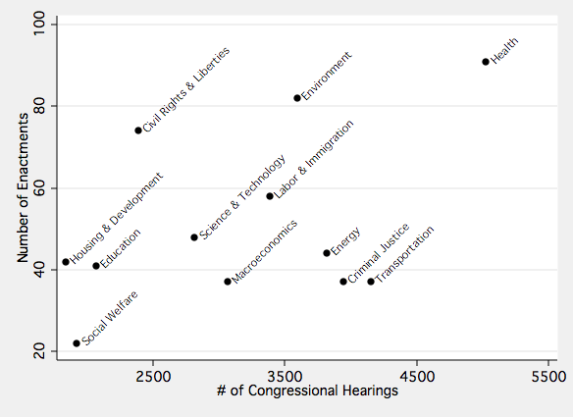
The figure depicts the relationship between the number of significant policy enactments in each issue area and the total number of congressional hearings in each issue area from 1945-2004.
Figure 3: Developmental and Episodic Reported Causes of Enactments by Policy Area

The figure depicts the percentage of policy enactments in each issue area that were reportedly affected by path dependence (including earlier policy choices that made the enactment more likely or eliminated alternatives) and focusing events (including wars and economic downturns). The reports are based on policy histories in each issue area covering significant policy enactments from 1945-2004.

Table 1: Reported Circumstances Associated with Policy Enactments in Issue Area Histories

 | Media Coverage | Public Opinion | Interest Groups | International | State or Local | Research
Civil Rights & Liberties | 18.9% | 24.3% | 66.2%* | 9.5% | 18.9%* | 21.6%*
Criminal Justice | 13.2% | 26.3% | 26.3%* | 0.0% | 13.2% | 39.5%
Education | 7.3% | 24.4% | 36.6% | 9.8% | 12.2% | 34.1%
Energy | 11.4% | 4.5%* | 36.4% | 4.5% | 18.2% | 36.4%
Environment | 19.5% | 24.4% | 67.1%* | 8.5% | 17.1% | 42.7%
Health | 10.1% | 12.8% | 35.8%* | 8.3% | 6.4% | 36.7%
Housing & Development | 14.3% | 11.9% | 57.1% | 0.0%* | 14.3% | 38.1%
Labor & Immigration | 18.0% | 27.9%* | 57.4% | 11.5% | 11.5% | 37.7%
Macroeconomics | 5.3% | 31.6%* | 34.2% | 10.5% | 10.5% | 34.2%
Science & Technology | 10.0% | 6.0%* | 32.0%* | 22.0%* | 2.0%* | 32.0%
Social Welfare | 24.0% | 28.0% | 48.0% | 0.0% | 20.0% | 44.0%
Transportation | 21.6% | 16.2% | 73.0%* | 0.0% | 5.4% | 37.8%
The table reports the percentage of enactments that involved each factor, according to policy historians. The two-tailed significance test is a t-test for difference in proportions between that issue and all other issue areas, *p<.05.
Figure 4: Issue Area Governing Networks: Civil Rights, Criminal Justice, Education, and Energy
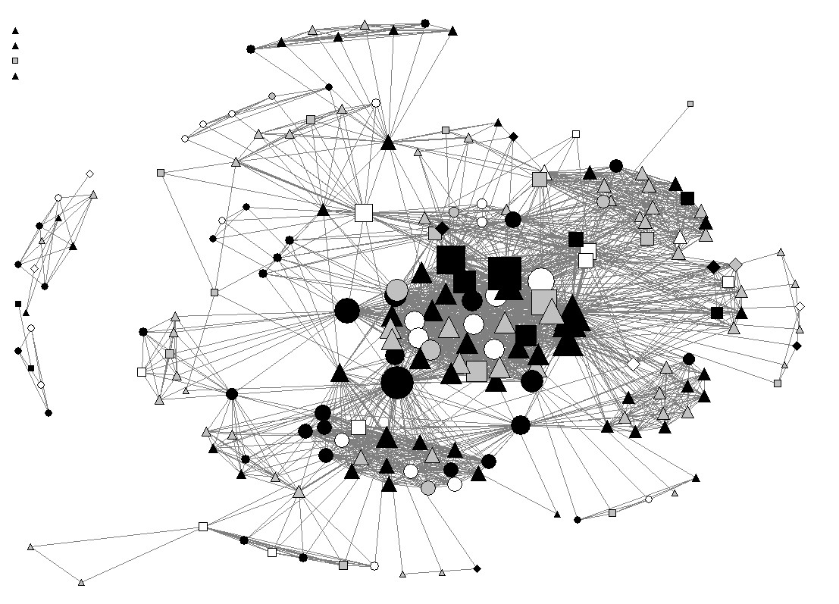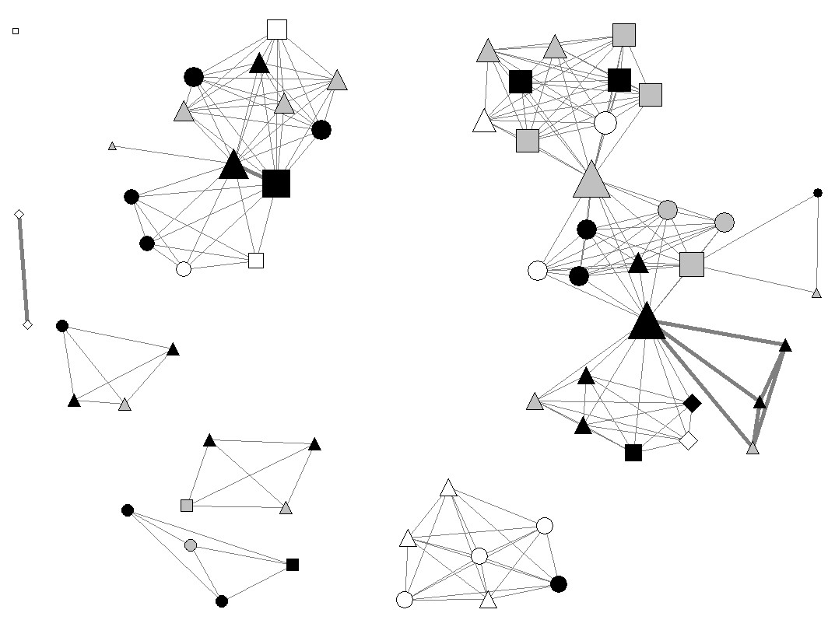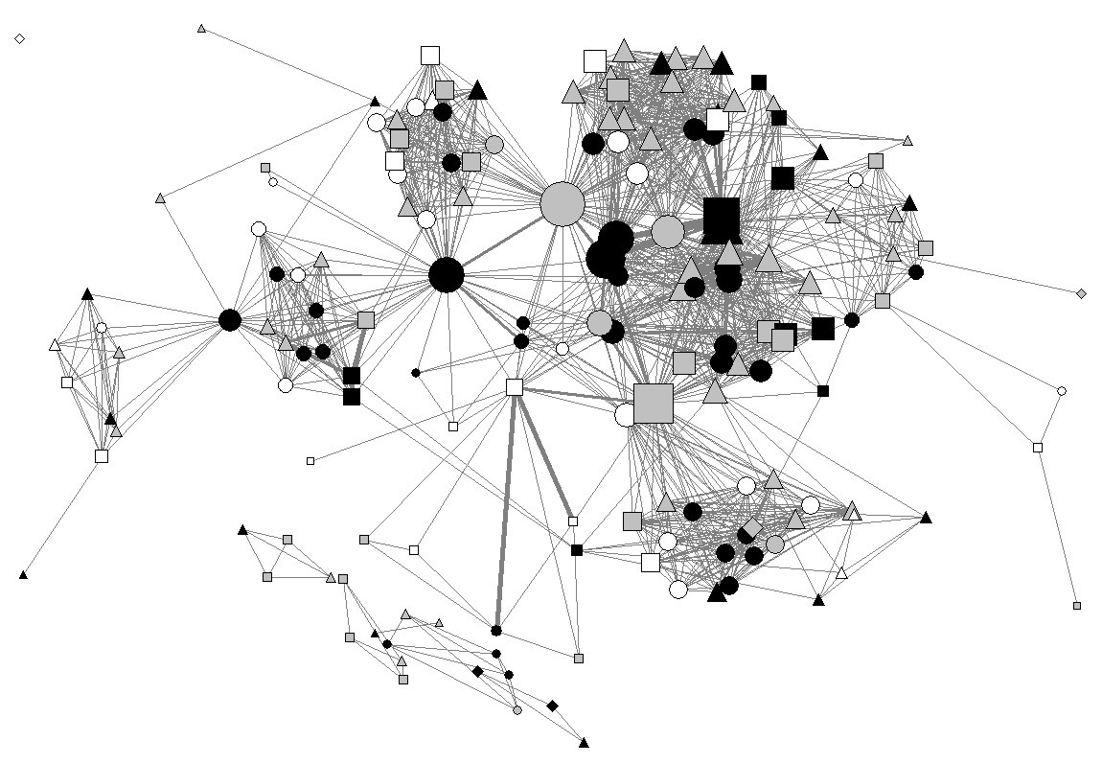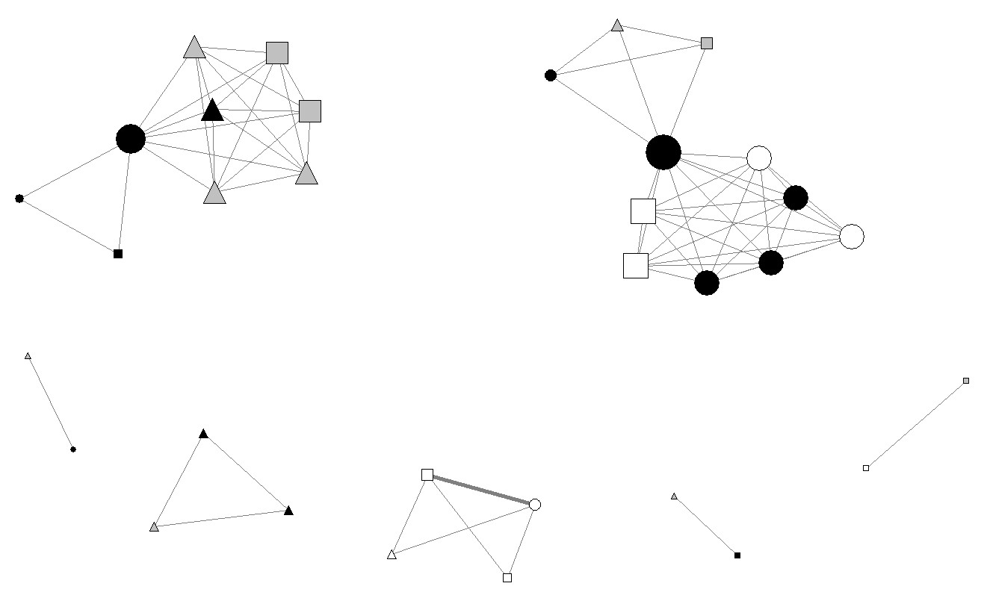
Civil Rights
Energy
Education
Criminal Justice
Nodes are actors credited with policy enactments in each area. Links connect actors credited with the same policy enactments. Democrats are black; Republicans are white; others are grey. Shape represents branch of government; circles are legislative; squares are executive; diamonds are judicial; triangles are non-governmental.
Figure 5: Issue Area Governing Networks: Environment, Health, Housing & Development, and Labor & Immigration
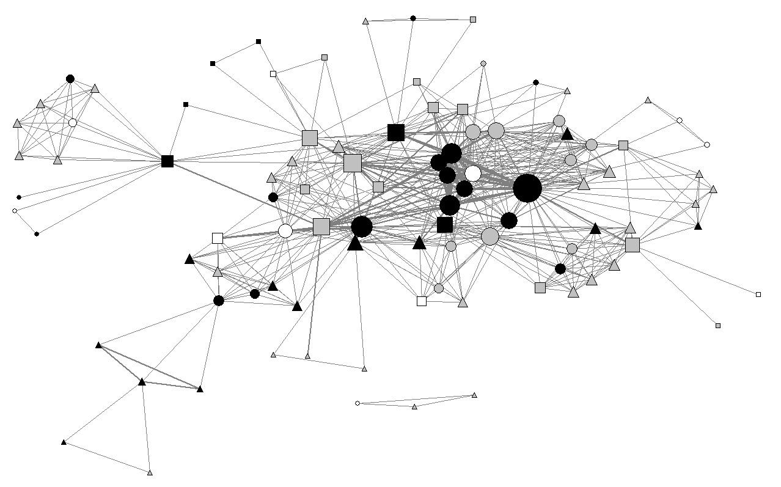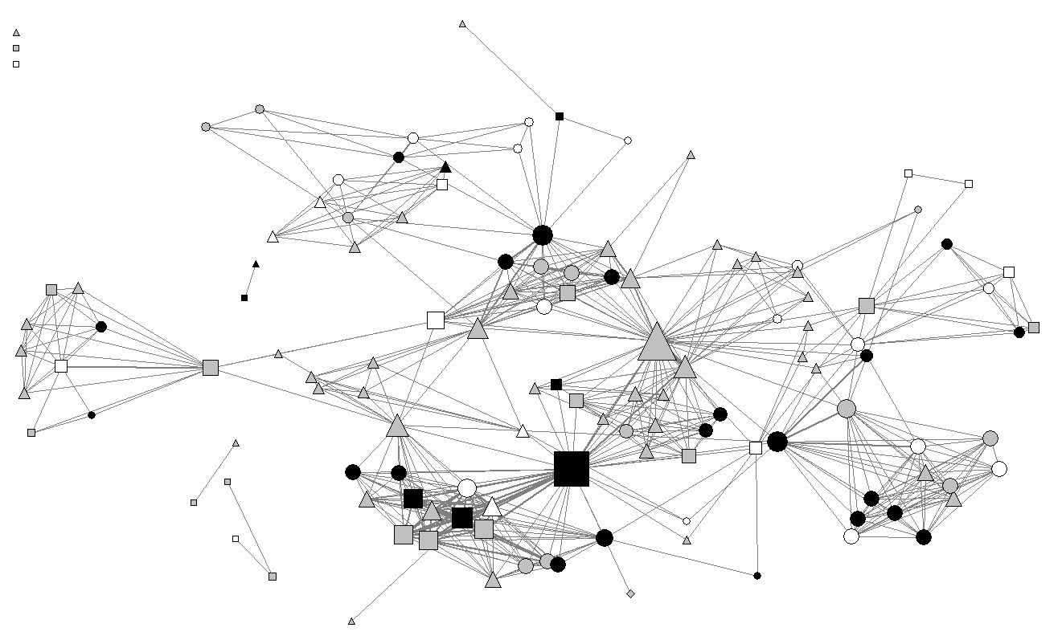
Health
Environment
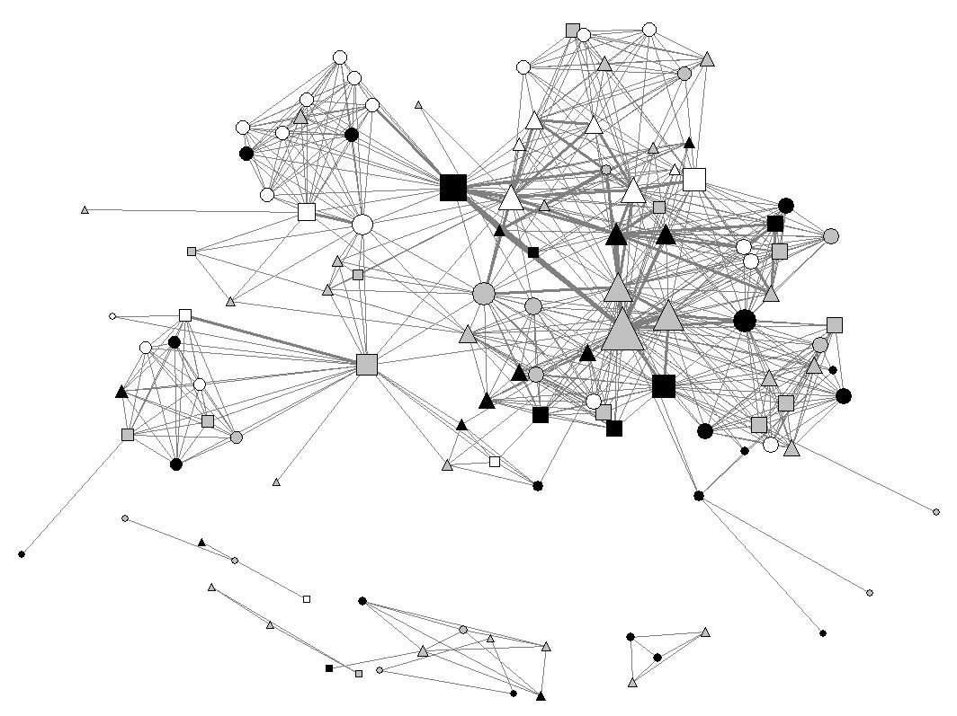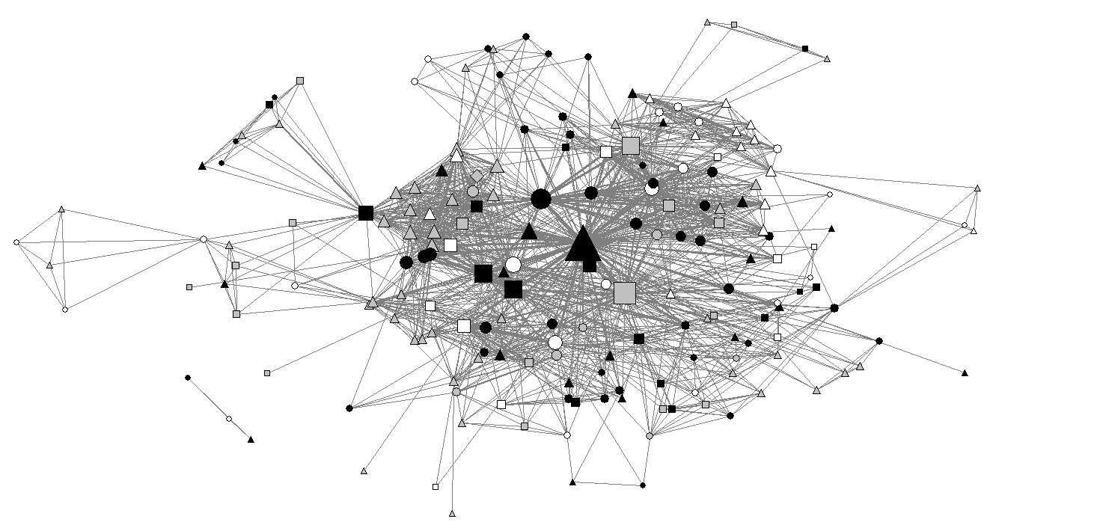
Housing & Development
Labor & Immigration
Nodes are actors credited with policy enactments in each area. Links connect actors credited with the same policy enactments. Democrats are black; Republicans are white; others are grey. Shape represents branch of government; circles are legislative; squares are executive; diamonds are judicial; triangles are non-governmental.
Figure 6: Issue Area Governing Networks: Macroeconomics, Science & Technology, Social Welfare, and Transportation
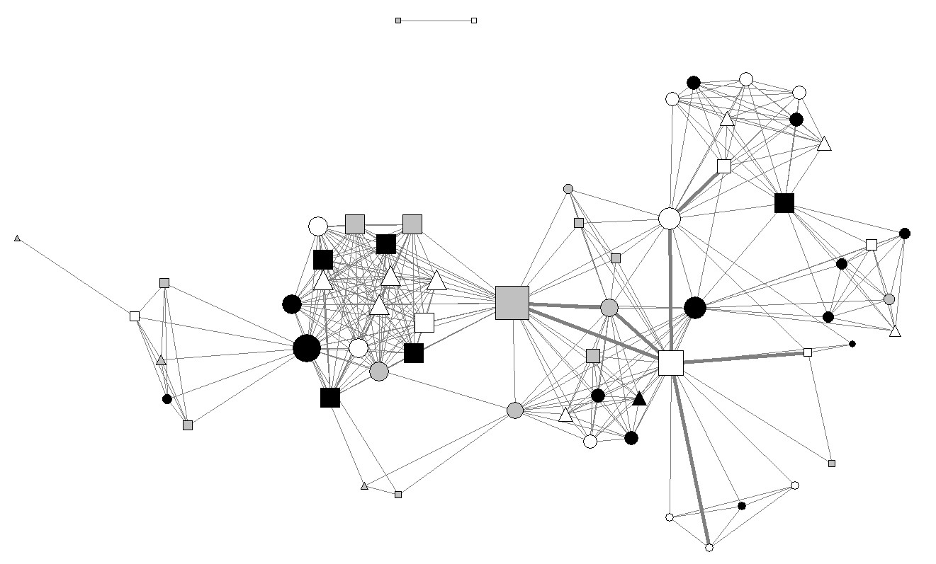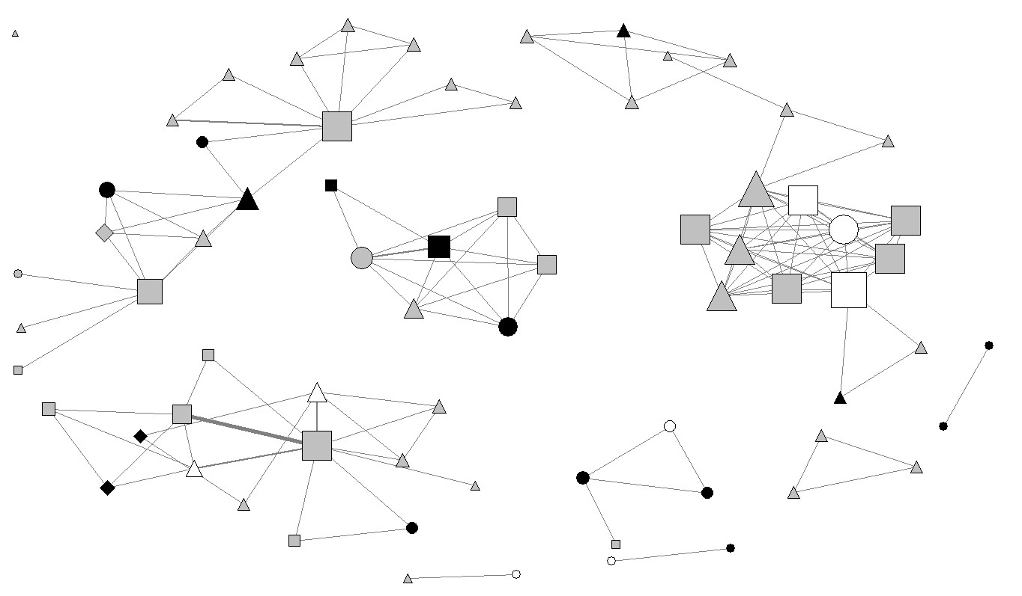
Science & Technology
Macroeconomics
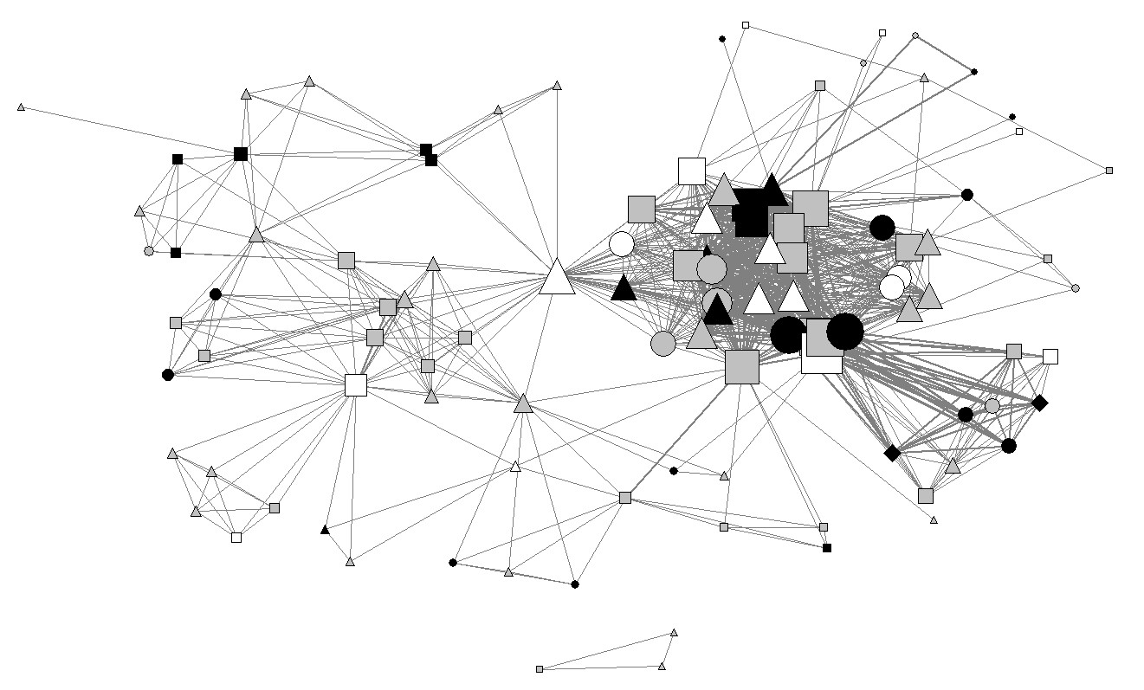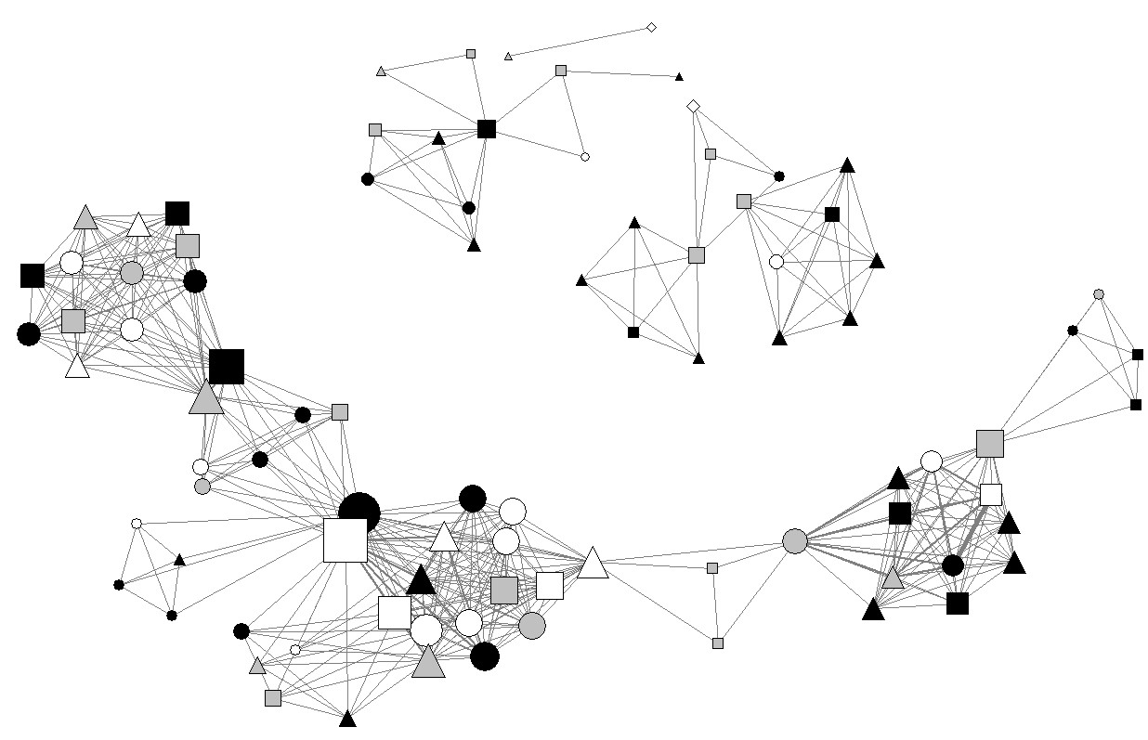
Transportation
Social Welfare
Nodes are actors credited with policy enactments in each area. Links connect actors credited with the same policy enactments. Democrats are black; Republicans are white; others are grey. Shape represents branch of government; circles are legislative; squares are executive; diamonds are judicial; triangles are non-governmental.
Table 2: Issue Area Governing Network Composition

 |  |  | Members of Congress |  | Interest Groups |  | Government Orgs.
 | Most Central (Degree) | Dominant Actor Type | # | Links | # | Links | # | Links
Civil Rights & Liberties | NAACP, JFK, MLK Jr. | Interest Groups | 58 | 19.2 | 51 | 22.4 | 12 | 19.9
Criminal Justice | ACLU, Amer. Bar Assn | Interest Groups | 17 | 5.8 | 16 | 7.6 | 7 | 7.1
Education | House Educ. Comm., Edith Green, NEA | Members of Congress | 54 | 19.5 | 27 | 16.1 | 15 | 16.1
Energy | Melvin Price, J. McCormick | Members of Congress | 11 | 5.6 | 4 | 3.25 | 2 | 2
Environment | John Blatnik, Ed Muskie | Members of Congress | 24 | 14.4 | 20 | 6.4 | 22 | 12.8
Health | Mary Lasker, Harry Truman | Members of Congress | 39 | 9.5 | 27 | 9.2 | 23 | 8.7
Housing & Development | Conf. Mayors, Municipal Assn. | Mixed | 39 | 9.7 | 29 | 14.6 | 23 | 9.7
Labor & Immigration | AFL-CIO, Ted Kennedy | Mixed | 62 | 14.6 | 59 | 17.4 | 23 | 15.3
Macroeconomics | Treasury Dept., Ronald Reagan | Members of Congress | 23 | 10 | 8 | 12.8 | 12 | 10.6
Science & Technology | FCC, Richard Nixon | Mixed | 13 | 2.6 | 12 | 2.8 | 12 | 2.8
Social Welfare | Reagan, Daniel P. Moynihan | Members of Congress | 26 | 9.8 | 15 | 8.3 | 16 | 8.6
Transportation | Gerald Ford, Ted Kennedy | Mixed | 17 | 15.8 | 27 | 16.9 | 26 | 19.2
The table reports characteristics of the actors credited with policy enactments in each issue area.
Table 3: Issue Area Governing Network Structural Characteristics

 |  |  | Core-Periphery |  |  |  | E-I Index
 | Size | Density | Fitness | Core Density | Degree  Centralization | Clustering Coefficient | Congress-Admin. | Bipartisan
Civil Rights & Liberties | 210 | .09 | .67 | 1.08 | 6.9% | .99 | -0.13 | -0.36
Criminal Justice | 64 | .1 | .41 | 1 | 10.7% | 1.02 | -0.39 | -0.37
Education | 170 | .1 | .48 | .64 | 9.8% | .97 | -0.17 | -0.12
Energy | 33 | .13 | .59 | 1 | 9.3% | 1.02 | -0.43 | -0.02
Environment | 98 | .14 | .54 | 1.52 | 9.4% | 1.14 | -0.24 | -0.25
Health | 125 | .08 | .01 | .08 | 7.4% | 1 | 0.05 | -0.29
Housing & Development | 119 | .1 | .48 | .87 | 15.5% | 1 | -0.35 | -0.06
Labor & Immigration | 191 | .09 | .51 | .74 | 14.9% | 1.13 | -0.24 | -0.10
Macroeconomics | 63 | .17 | .56 | .83 | 17.6% | .98 | -0.02 | -0.01
Science & Technology | 70 | .06 | .25 | .26 | 3.6% | 1 | -0.11 | -0.38
Social Welfare | 90 | .11 | .54 | 1.11 | 6.8% | 1 | -0.07 | 0.03
Transportation | 107 | .22 | .82 | 1.83 | 15.3% | 1.21 | -0.01 | -0.07
The table reports structural characteristics of the affiliation networks associated with policy enactments in each issue area.

Table 4: The Relative Features of Each Issue Area’s Politics

 | Type of Policymaking | Relevant Circumstances | Network Composition | Network Structure
Civil Rights & Liberties | Multi-branch, frequent, and path dependent | High media, public, and state/local influence but low research influence | Large network with many interest groups | Core-periphery structure but low centralization
Criminal Justice | Disproportionately judicial enactments, infrequent | High research and public opinion influence but no international influence | Small network with central interest groups | Executive-congressional divide
Education | Path dependent infrequent enactments by Congress and the President | No dominant influential factors | Large network dominated by members of Congress | Core with satellite clusters
Energy | Disproportionately administrative enactments, event-driven policymaking | Low public opinion and high state/local influence | Small bipartisan network, concentrated in Congress | Executive-congressional divide
Environment | Many enactments with congressional dominance | High media, state/local, and research influence | Disproportionately Democratic network | Dense with high clustering
Health | Many enactments with high congressional interest | No dominant influential factors | Large network, dominated by members of Congress | Sparse with no core but high inter-branch ties
Housing & Development | Path dependent infrequent enactments | High interest group and state/local influence but no international influence | Large diverse network | Centralized network with executive-congressional divide
Labor & Immigration | Multi-branch enactments. | High media, public opinion, international, and interest group influence | Diverse, centralized around AFL-CIO | Large sparse network, with high clustering

 | Type of Policymaking | Relevant Circumstances | Network Composition | Network Structure
Macroeconomics | Event-driven infrequent enactments | High public opinion but low media influence | Congressionally dominated | Centralized, dense network with high inter-branch ties
Science & Technology | Disproportionately administrative enactments | Low public opinion and state/local influence but high international influence | Diverse, with many government organizations | Sparse, disconnected network with no core
Social Welfare | Infrequent enactments | High media, public opinion, and state/local influence but no international influence | Congress-dominated network | Decentralized, with bipartisan ties
Transportation | High congressional interest but infrequent enactments | High interest group influence; no international influence | Large diverse network, with many government organizations | Centralized core-periphery network; high clustering and inter-branch ties
The table reports descriptions of where each issue area stands out among the others, based on the analysis of policy area histories conducted here.

References
Baumgartner, Frank R. and Bryan D. Jones. 1993. Agendas and Instability in American Politics. Chicago: University of Chicago Press.
Berry, Jeffrey. M. 1989. The Interest Group Society, 5th ed. New York: HarperCollins Publishers.
Cross, Christopher T. 2003. Political Education: National Policy Comes of Age. New York: Teachers College Press.
Dahl, Robert A. 1961. Who Governs? Democracy and Power in an American City. New Haven: Yale University Press.
Graham Jr., Otis L, ed. 2000. Environmental Politics and Policy, 1960s-1990s. University Park: Pennsylvania State University Press.
Heclo, Hugh. 1978. “Issue Networks and the Executive Establishment.” In The New American Political System. Washington: American Enterprise Institute.
Lowi, Theodore. 1964. “American Business, Public Policy, Case-Studies, and Political Theory.” World Politics 16(4): 677-715.
Katznelson, Ira and John S. Lapinski. 2006. “The Substance of Representation: Studying Policy Content and Legislative Behavior.” In The Macropolitics of Congress, E. Scott Adler and John Lapinski, eds. Princeton: Princeton University Press, 96-121.
Kingdon, John W. 2003. Agendas, Alternatives and Public Policies, 2nd Ed. New York: Addison-Wesley.
Marsh, David and R. A. W. Rhodes. 2004. “Policy Communities and Issue Networks: Beyond Typology,” In Social Networks: Critical Concepts in Sociology, John Scott, ed. London: Routledge.
Mayhew, David R. 2005. Divided We Govern: Party Control, Lawmaking, and Investigations, 1946-2002. New Haven: Yale University Press.
Petrocik, John R. 1996. “Issue Ownership in Presidential Elections, with a 1980 Case Study.” American Journal of Political Science 40(3): 825-50.
Pierson, Paul. 2004. Politics in Time: History, Institutions, and Social Analysis. Princeton: Princeton University Press.
Portney, Paul R. and Robert N. Stavins, eds. 2000. Public Policies for Environmental Protection. Washington: Resources for the Future.
Sabatier, Paul A. and Hank C. Jenkins-Smith. 1993. Policy Change and Learning: An Advocacy Coalition Approach. Boulder, CO: Westview Press.
Schickler, Eric. 2001. Disjointed Pluralism: Institutional Innovation and the Development of the U.S. Congress. Princeton: Princeton University Press.
Shull, Steven A. 1999. American Civil Rights Policy from Truman to Clinton: The Role of Presidential Leadership. Armonk, NY: M.E. Sharpe.
Smith, Kevin B. 2002. “Typologies, Taxonomies, and the Benefits of Policy Classification.” Policy Studies Journal 30(3): 379-395.
Spring, Joel. 1993. Conflict of Interests: The Politics of American Education. New York: Longman.
Stetson, Dorothy McBride. 1997. Women’s Rights in the USA. New York: Garland Publishing.
Vedung, Evert. 2003. “Policy Instruments: Typologies and Theories.” In Carrots, Sticks, and Sermons: Policy Instruments and their Evaluation, Evert Vedung, Ray Rist, and Marie-Louise Bemelmans-Videc, eds. New Brunswick, NJ: Transaction Publishers.
Wasserman, Stanley and Katherine Faust. 1994. Social Network Analysis: Methods and Applications. Cambridge: Cambridge University Press.
Weible, Christopher M., Paul Sabatier, and Kelly McQueen. 2009. “Themes and Variations: Taking Stock of the Advocacy Coalition Framework.” Policy Studies Journal 37(1): 121-40.
Wilson, James Q. 1980. “The Politics of Regulation.” In The Politics of Regulation, James Q. Wilson, ed. New York: Basic Books, 357-94.
Appendix: Coded Sources
Civil Rights and Liberties – 24 Books, 4 Articles
Alley, Robert S. 1994. School Prayer: The Court, the Congress and the First Amendment. Amherst, NY: Prometheus Books.
Ashmore, Harry S. 1994. Civil Rights and Wrongs. New York: Pantheon.
Bok, Marcia. 1992. Civil Rights and the Social Programs of the 1960's. Westport, CT: Praeger Publishers.
Browne-Marshall, Gloria J. 2007. Race, Law and American Society. New York: Routledge.
Burstein, Paul. 1985. Discrimination, Jobs, and Politics: The Struggle for Equal Employment Opportunity In the United States since the New Deal. Chicago: University of Chicago Press.
Conway, M. Margaret, David W. Ahern, and Gertrude A. Steuernagel. 1999. Women and Public Policy. Washington: CQ Press.
D'Emilio, John, William B. Turner, and Urvashi Vaid. 2000. Creating Change: Sexuality, Public Policy, and Civil Rights. New York: St. Martin’s.
Edelman, Marian Wright. 1973. “Southern School Desegregation. 1954 – 1973: A Judicial-Political Overview.” The ANNALS of the American Academy of Political and Social Science 407 (1): 32-42.
Foerstel, Herbert N. 1999. Freedom of Information and the Right to Know. Santa Barbara, CA: Greenwood Publishing Group.
Graham, Hugh Davis. 1990. The Civil Rights Era: Origins and Development of National Policy, 1960-1972. Oxford: Oxford University Press.
Graham, Hugh Davis 1992. “The Origins of Affirmative Action: Civil Rights and the Regulatory State.” The ANNALS of the American Academy of Political and Social Science 523 (1): 50-62.
Harrison, Cynthia. 1988. On Account of Sex. Berkeley: University of California Press.
Jenness, Valerie and Ryken Grattet. 2001. Making Hate A Crime: From Social Movement to Law Enforcement. New York: Russell Sage Foundation.
Koltlowski, Dean. 2005. “With All Deliberate Delay: Kennedy, Johnson, and School Desegregation.” Journal of Policy History 17 (2): 155-192.
Landsberg, Brian K. 1997. Enforcing Civil Rights: Race Discrimination and the Department of Justice. Lawrence: University Press of Kansas.
Laughlin, Kathleen A. 2000. Women's Work and Public Policy: A History of the Women's Bureau, U.S. Department of Labor, 1945-1970. Boston: Northeastern University Press.
Lawson, Steven F. 1997. Running For Freedom: Civil Rights and Black Politics in America Since 1941. New York: McGraw-Hill.
Lawson, Steven F. 1976. Black Ballots: Voting and Rights in the South 1944-1969. New York: Columbia University Press.
Layton, Azza Salama. 2000. International Politics and Civil Rights Policies in the United States, 1941-1960. Cambridge: Cambridge University Press.
Lichtman, Allan. 1969. “The Federal Assault Against Voting Discrimination in the Deep South, 1957-1967.” Journal of Negro History 54 (4): 346-367.
Riddlesperger Jr., James and Donald Jackson. 1995. Presidential Leadership and Civil Rights Policy. Westport, CT: Greenwood.
Rimmerman, Craig A., Kenneth D. Wald, and Clyde Wilcox, eds. 2000. The Politics of Gay Rights. Chicago: University of Chicago Press.
Schrecker, Ellen. 2002. The Age of McCarthyism. New York: St. Martin’s Press.
Shull, Steven A. 1999. American Civil Rights Policy from Truman to Clinton: The Role of Presidential Leadership. Armonk, NY: M.E. Sharpe.
Skrentny, John D. 2002. The Minority Rights Revolution. Cambridge: Belknap Press of Harvard University Press.
Solinger, Rickle. 1998. Abortion Wars: A Half Century of Struggle, 1950 - 2000. Berkeley: University of California Press.
Stetson, Dorothy McBride. 1997. Women’s Rights in the USA. New York: Garland Publishing.
Switzer, Jaqueline Vaughn 2003. Disabled Rights: American Disability Policy and the Fight for Equality. Washington: Georgetown University Press.

Criminal Justice – 7 Books
Jenness, Valerie and Ryken Grattet. 2001. Making Hate A Crime: From Social Movement to Law Enforcement. New York: Russell Sage Foundation.
Marion, Nancy. 2007. A Primer in the Politics of Criminal Justice, 2nd ed. Monsey, NY: Criminal Justice Press.
Marion, Nancy. 1994. A History of Federal Crime Control Initiatives, 1960-1993. Westport, CT: Praeger Publishers.
Spitzer, Robert J. 2007. The Politics of Gun Control, 4th ed. Washington, DC: CQ Press.
Stolz, Barbara. 2001. Criminal Justice Policy Making: Federal Roles and Processes. Westport, CT: Praeger Publishers.
Walker, Samuel. 1980. Popular Justice: A History of American Criminal Justice. Oxford: Oxford University Press.
Wilson, Harry L. 2006. Guns, Gun Controls, and Elections. Lanham, MD: Rowman & Littlefield Publishers.

Education – 12 Books, 4 Articles
Anderson, Lee W. 2007. Congress and the Classroom: From the Cold War to ‘No Child Left Behind.’ University Park: Pennsylvania State University Press.
Brademas, John. 1987. The Politics of Education: Conflict and Consensus on Capitol Hill. Norman: University of Oklahoma Press.
Cross, Christopher T. 2003. Political Education: National Policy Comes of Age. New York: Teachers College Press.
Davies, Gareth. 2007. See Government Grow: Education Politics from Johnson to Reagan. Lawrence: University Press of Kansas.
DeBray, Elizabeth H. 2006. Politics, Ideology, and Education: Federal Policy During the Clinton and Bush Administrations. New York: Teacher’s College Press.
Fraser, James W. 1999. Between Church and State: Religion and Public Education in a Multicultural America. New York: St. Martin’s Press.
Hill, Paul. 2000. “The Federal Role in Education.” In Brookings Papers on Education Policy, ed. Diane Ravitch. Washington: Brookings Institution.
Jeynes, William H. 2007. American Educational History: School, Society, and the Common Good. New York: Russell Sage Foundation.
Moran, Rachel. 1988. “The Politics of Discretion: Federal Intervention in Bilingual Education.” California Law Review 76: 1249-1250.
Osgood, Robert L. 2008. The History of Special Education: A Struggle for Equality in American Public Schools. Santa Barbara, CA: Greenwood Publishing Group.
Ravitch, Diane. 1985. The Troubled Crusade: American Education 1945-1980. New York: Basic Books.
Rudy, Willis 2003. Building America's Schools and Colleges: The Federal Contribution. Cranbury, NJ: Cornwall Books.
Spring, Joel. 1993. Conflict of Interests: The Politics of American Education. New York: Longman.
Strach, Patricia. 2009. “Making Higher Education Affordable: Policy Design in Postwar America.” Journal of Policy History 21 (1): 61-88.
Thomas, Janet and Kevin Brady. 2005. “The Elementary and Secondary Education Act at 40: Equity, Accountability, and the Evolving Federal Role in Public Education.” Review of Research in Education 29 (1): 51-67.
Vinovskis, Maria A. 2005. The Birth of Head Start: Preschool Education Policies in the Kennedy and Johnson Administrations. Chicago: University of Chicago Press.

Energy – 8 Books
Duffy, Robert J. 1997. Nuclear Politics in America: A History and Theory of Government Regulation. Lawrence, KS: University of Kansas Press.
Goodwin, Craufurd D. W. 1981. Energy Policy in Perspective: Today’s Problems, Yesterday’s Solutions. Washington DC: Brokings.
Jasper, James M. 1990. Nuclear Politics: Energy and the State in the United States, Sweden, and France. Princeton, NJ: Princeton University Press.
Kash, Don E. and Robert Rycroft. 1984. U.S. Energy Policy: Crisis and Complacency. Norman: University of Oklahoma Press.
Laird, Frank N. 2001. Solar Energy, Technology Policy, and Institutional Values. Cambridge: Cambridge University Press.
Randall, Stephen J. 2005. United States Foreign Oil Policy Since World War I (2nd ed). Montreal: McGill-Queen’s University Press.
Tugwell, Franklin. 1988. The Energy Crisis and the American Political Economy: Politics and Markets in the Management of Natural Resources. Stanford: Stanford University Press.
Vietor, Richard H. K. 2008. Energy Policy in America since 1945: A Study of Business-Government Relations. Cambridge: Cambridge University Press.

Environment – 11 Books
Andrews, Richard N. L. 2006. Managing the Environment, Managing Ourselves: A History of American Environmental Policy, 2nd Ed. New Haven: Yale University Press.
Fretwell, Holly Lippke. 2009. Who Is Minding the Federal Estate?: Political Management of America's Public Lands. Lanham, MD: Lexington Books.
Graham Jr., Otis L, ed. 2000. Environmental Politics and Policy, 1960s-1990s. University Park: Pennsylvania State University Press.
Hayes, Samuel P. 2000. A History of Environmental Politics Since 1945. Pittsburgh: University of Pittsburgh Press
Klyza, Christopher McGrory and David J. Sousa. 2008. American Environmental Policy, 1990-2006: Beyond Gridlock. Cambridge: MIT Press.
Milazzo, Paul Charles. 2006. Unlikely Environmentalists: Congress and Clean Water, 1945-1972. Lawrence: University Press of Kansas.
Portney, Paul R. and Robert N. Stavins, eds. 2000. Public Policies for Environmental Protection. Washington: Resources for the Future.
Sussman, Glenn, Byron Daynes, and Jonathan P. West. 2001. American Politics and the Environment. New York: Longman.
Tzoumis, Kelly. 2009. Environmental Policymaking in Congress: The Role of Issue Definitions in Wetlands, Great Lakes and Wildlife Policies. New York: Routledge.
Vig, Norman J. and Michael E. Kraft, eds. 2000. Environmental Policy: New Directions. Washington: Congressional Quarterly Press.
Weber, Edward P. 1998. Pluralism by the Rules: Conflict and Cooperation in Environmental Regulation. Washington: Georgetown University Press.

Health – 18 Books
Aaron, Henry. 1995. The Problem That Won’t Go Away: Reforming U.S. Health Care Financing. Washington, DC: Brookings Institution Press.
Brown, Lawrence, ed. 1987. Health Policy in Transition: A Decade of Health Politics, Policy, and Law. Durham, NC: Duke University Press.
Field, Robert I. 2006. Health Care Regulation in America: Complexity, Confrontation, and Compromise. New York: Oxford University Press.
Frank, Richard G., and Sherry A. Glied. 2006. Better But Not Well: Mental Health Policy in the United States Since 1950. Baltimore: Johns Hopkins University Press.
Funigiello, Philip J. 2005. Chronic Politics: Health Care Security from FDR to George W. Bush. Lawrence: University Press of Kansas.
Hacker, Jacob. 2002. The Divided Welfare State: The Battle over Public and Private Social Benefits in the United States. Cambridge: Cambridge University Press.
Kronenfeld, Jennie Jacobs. 1997. The Changing Federal Role in U.S. Health Care Policy. Westport, CT: Praeger Publishers.
Longest, Beaufort. 2010. Health Policymaking in the United States, 5th ed. Chicago, IL: Health Administration Press.
Marcus, Alan. 1993. Health Care Policy in Contemporary America. University Park: Pennsylvania State University Press.
Mechanic, David 1986. From Advocacy to Allocation: Evolving American Health Care System. New York: Free Press.
Morone, James A., Theodor J. Litman, and Leonard S. Robins. 2008. Health Politics and Policy, 4th ed. Florence, KY: Delmar Cengage Learning.
Mueller, Keith. 1993. Health Care Policy in the United States. Lincoln, NE: University of Nebraska Press.
Patel, Kant and Mark Rushefsky. 2006. Health Care Politics and Policy in America. Armonk, NY: M. E. Sharpe.
Quadagno, Jill. 2005. One Nation, Uninsured: Why the U.S. has No National Health Insurance. Oxford: Oxford University Press.
Stevens, Rosemary. 2007. The Public-Private Health Care State. New Brunswick, NJ: Transaction Publishers.
Strickland, Stephen P. 1972. Politics, Science, and Dread Disease: A Short History of United States Medical Research Policy. Cambridge: Harvard University Press.
Studlar, Donley T. 2002. Tobacco Control: Comparative Politics in the United States and Canada. Toronto: University of Toronto Press.
Weissert, Carol and William Weissert. 2006. Governing Health: The Politics of Health Policy. Baltimore, MD: The Johns Hopkins University Press.

Housing & Community Development – 11 Books, 8 Articles
Caves, Roger W. 1989. “An Historical Analysis of Federal Housing Policy from the Presidential Perspective: An Intergovernmental Focus.” Urban Studies 26(1): 59-76.
Cooper, Clarence A. and Frank R. Cooper. 2002. “Where the Rubber Meets the Road: CRA's Impact on Distressed Communities.” In Public Policies for Distressed Communities Revisited, eds. F. Stevens Redburn and Terry F. Buss. Lexington, MA: Lexington Books.
Dreussi, Amy Shriver and Peter Leahy. 2002. “Urban Development Action Grants Revisited.” Review of Policy Research 17 (2): 120-137.
Ferguson, Ronald F. and William T. Dickens. 1999. Urban Problems and Community Development. Washington, DC: Brookings Institutions Press.
Gelfand, Mark I. 1975. A Nation of Cities: The Federal Government and Urban America, 1933-1965. Oxford: Oxford University Press.
Goering, John M. 1986. Housing Desegregation and Federal Policy. Chapel Hill: The University of North Carolina Press.
Graham, Hugh Davis. 2000a. “The Surprising Career of Federal Fair Housing Law.” Journal of Policy History 12(2): 215-232.
Gunther, John J. 1990. Federal-City Relations in the United States: The Role of the Mayors in Federal Aid to Cities. Newark, DE: University of Delaware Press.
Hays, R. Allen. 1995. The Federal Government and Urban Housing: Ideology and Change in Public Policy. Albany, NY: State University of New York Press.
Hunt, D. Bradford. 2005. “How Did Public Housing Survive the 1950s.” Journal of Policy History 17(2): 193-216.
James, Franklin J. and Ron Kirk. 2002. “Can Urban Policies Be Responsive to Changing Urban Needs?” In Public Policies for Distressed Communities Revisited, eds. F. Stevens Redburn and Terry F. Buss. Lexington, MA: Lexington Books.
Keith, Nathaniel S. 1974. Politics and the Housing Crisis Since 1930. New York: Universe Books.
Martin, Curtis H. and Robert A Leone . 1977. Local Economic Development The Federal Connection. Lexington, MA: Lexington Books.
Mitchell, Paul. 1985. Federal Housing Policy and Programs: Past and Present. Piscataway, NJ: Rutgers University Press.
Peters, Alan H. and Peter S. Fisher. 2002. State Enterprise Zone Programs: Have They Worked? Kalamazoo, MI: W.E. Upjohn Institute.
Schwartz, Alex F. 2006. Housing Policy in the United States: An Introduction. London: Routledge
Sidney, Mara S. 2003. Unfair Housing: How National Policy Shapes Community Action. Lawrence: University of Kansas Press.
Snow, Douglas R. 2002. “Strategic Planning and Enterprise Zones.” Review of Policy Research 17 (2): 13-28.
Teaford, Jon C. 1993. The Twentieth-Century American City: Problem, Promise, and Reality. Baltimore: Johns Hopkins University Press.

Labor and Immigration – 15 Books, 1 Article
Baumer, Donald C. 1985. The Politics of Unemployment. Washington: CQ Press.
Gimpel, James and James Edwards. 1998. The Congressional Politics of Immigration Reform. New York: Longman
Gross, James A. 1985. “Conflicting Statutory Purposes: Another Look at Fifty Years of NLRB Law Making.” Industrial and Labor Relations Review 39(1): 7-18.
LeMay, Michael C. 1994. Anatomy of a Public Policy: The Reform of Contemporary American Immigration Law. Westport, CT: Praeger Publishers.
Lichtenstein, Nelson. 2003. State of the Union: A Century of American Labor. Princeton: Princeton University Press.
Moreno, Paul D. 1999. From Direct Action to Affirmative Action-Fair Employment Law and Policy in America. Baton Rouge: Louisiana State University Press.
Newton, Lina. 2008. Illegal, Alien, or Immigrant: the Politics of Immigration Reform. New York: NYU Press.
Nordlund, Willis. 1997. The Quest for a Living Wage. Santa Barbara, CA: Greenwood Press.
Ong Hing, Bill. 2003. Defining America Through Immigration Policy. Philadelphia: Temple University Press.
Rockoff, Hugh. 1984. Drastic Measures: A History of Wage & Price Controls in the United States. Cambridge: Cambridge University Press.
Shanks, Cheryl. 2001. Immigration and the Politics of American Sovereignty, 1890-1990. Ann Arbor: University of Michigan Press.
Togman, Jeffrey M. 2001. The Ramparts of Nations. Santa Barbara, CA: Greenwood Press.
Waltman, Jerold. 2000. The Politics of the Minimum Wage. Champaign: University of Illinois Press.
Weir, Margaret. 1993. Politics and Jobs: The Boundaries of Employment Policy in the United States. Princeton: Princeton University Press.
Wong, Carolyn. 2006. Lobbying for Inclusion: Rights Politics and the Making of Immigration Policy. Palo Alto: Stanford University Press.
Zieger, Robert H. 2002. American Workers, American Unions. Baltimore: Johns Hopkins University Press.

Macroeconomics (Tax and Budget) – 6 Books
Brownlee, W. Elliot. 2004. Federal Taxation in America: A Short History. Cambridge: Cambridge University Press.
Makin, John and Norman Ornstein. 1994. Debt and Taxes: How America Got into Its Budget Mess and What to Do About It. New York: Crown Publishing Group.
Orfield, Gary. 1975. Congressional Power: Congress and Social Change. Boston, MA: Houghton Mifflin Harcourt Press.
Schick, Allen. 2000. The Federal Budget: Politics, Policy, Process. Washington: Brookings Institution Press.
Steuerle, C. Eugene. 2004. Contemporary U.S. Tax Policy. Washington: Urban Institute Press.
Sundquist, James L. 1968. Politics and Policy: The Eisenhower, Kennedy, and Johnson Years. Washington: Brookings Institution Press.

Science & Technology – 15 Books, 5 Articles
Bryner, Gary C., ed. 1992. Science, Technology, and Politics: Policy Analysis in Congress. Boulder, CO: Westview Press.
DiFilippo, Anthony. 1990. From Industry to Arms: The Political Economy of High Technology. Santa Barbara, CA: Greenwood Publishing Group.
Eisenmann, Thomas R. 2000. “The U.S. Cable Television Industry, 1948-1995: Managerial Capitalism in Eclipse.” The Business History Review 74(1): 1-40.
Guston, David. 2007. Between Politics and Science: Assuring the Integrity and Productivity of Research. Cambridge: Cambridge University Press.
Guston, David H. and Daniel Sarewitz, eds. 2006. Shaping Science and Technology Policy: The Next Generation of Research. Madison: University of Wisconsin Press.
Jaffe, Adam B. 2000. “The U.S. Patent System in Transition: Policy Innovation and the Innovation Process.” Research Policy 29(4): 531-557.
Jasanoff, Sheila. 1990. The Fifth Branch: Science Advisors as Policymakers. Cambridge: Harvard University Press.
Johnson, Ann. 2004. “The End of Pure Science: Science Policy from Bayh-Dole to the NNI.” In Discovering the Nanoscale, D. Baird, A. Nordmann & J. Schummer, eds. Amsterdam: IOS Press.
Kraemer, Sylvia. 2006. Science And Technology Policy in United States: Open Systems in Action. Piscataway, NJ: Rutgers University Press.
Lane, Neal. 2008. “US Science and Technology: An Uncoordinated System that Seems to Work.” Technology in Society 30(3-4): 248-63.
Launius, Roger D. and Howard E McCurdy. 1997. Spaceflight and the Myth of Presidential Leadership. Champaign: University of Illinois Press.
Marcus, Alan I. and Amy Sue Bix. 2007. The Future is Now: Science & Technology Policy in America since 1950. Amherst, NY: Prometheus Books.
Marks, Harry. 2000. The Progress of Experiment: Science and Therapeutic Reform in the United States, 1900-1990. Cambridge: Cambridge University Press.
McDougall, Walter A. 2008. The Heavens and the Earth: A Political History of the Space Age. Baltimore: The Johns Hopkins University Press.
Moore, Kelly. 2008. Disrupting Science: Social Movements, American Scientists, and the Politics of the Military, 1945-1975. Princeton: Princeton University Press.
Savage, James D. 1999. Funding Science in America: Congress, Universities, and the Politics of the Academic Pork Barrel. Cambridge: Cambridge University Press.
Sheingate, Adam D. 2006. “Promotion vs. Precaution: The Evolution of Biotechnology Policy in the United States.” British Journal of Political Science 36(2): 243-268.
Smith, Bruce L.R. 1990. American Science Policy Since World War II. Washington: Brookings Institution Press.
Sterling, Christopher H., Phyllis W. Bernt, Martin B. H. Weiss. 2006. Shaping American Telecommunications: A History of Technology, Policy, and Economics. Mahwah, NJ: Lawrence Erlbaum Associates.
Wang, Zuoyue. 2008. In Sputnik's Shadow: The President's Science Advisory Committee and Cold War America. New Brunswick, NJ: Rutgers University Press.

Social Welfare – 9 Books
Beland, Daniel. 2007. Social Security: History & Politics from the New Deal to the Privatization Debate. Lawrence: University of Kansas Press.
Berkowitz, Edward D. 1991. America’s Welfare State: From Roosevelt to Reagan. Baltimore: Johns Hopkins University Press.
Goldberg, Gertrude Schaffer and Sheila D. Collins. 2001. Washington’s New Poor Law: Welfare Reform and the Roads Not Taken, 1935 to the Present. New York: Apex Press.
Howard, Christopher. 2006. The Welfare State Nobody Knows: Debunking Myths About U.S. Social Policy. Princeton: Princeton University Press.
Howard, Christopher. 1999. The Hidden Welfare State: Tax Expenditures and Social Policy in the United States. Princeton: Princeton University Press.
Mink, Gwendolyn and Rickie Solinger, eds. 2003. Welfare: A Documentary History of U.S. Policy and Politics. New York: NYU Press.
Patterson, James T. 2000. America’s Struggle Against Poverty in the Twentieth Century. Cambridge: Harvard University Press.
Schieber, Sylvester J. and John B. Shoven. 1999. The Real Deal: The History and Future of Social Security. New Haven: Yale University Press.
Skocpol, Theda, ed. 1995. Social Policy in The United States: Future Possibilities in Historical Perspective. Princeton: Princeton University Press.

Transportation – 10 Books, 1 Article
Brown, Anthony E. 1987. The Politics of Airline Deregulation. Knoxville: University of Tennessee Press.
Derthick, Martha and Paul J. Quirk. 1985. The Politics of Deregulation. Washington: Brookings Institution Press.
Digger, Robert Jay. 2003. American Transportation Policy. Santa Barbara, CA: Greenwood Publishing Group.
Gertz, Carsten. 2003. “Lessons from a Landmark U.S. Policy for Transportation, Land Use and Air Quality, and Implications for Policy Changes in Other Countries.” International Social Science Journal 55(176): 307–17.
Jones, David W. 2008. Mass Motorization and Mass Transit: An American History and Policy Analysis. Bloomington: Indiana University Press.
Lewis, Tom. 1999. Divided Highways: Building the Interstate Highways, Transforming American Life. New York; Penguin.
Robyn, Dorothy. 1987. Braking the Special Interests: Trucking Deregulation and the Politics of Policy Reform. Chicago: University of Chicago Press.
Rose, Mark H., Bruce E. Seely, Paul F. Barrett. 2006. The Best Transportation System in the World: Railroads, Trucks, Airlines, and American Public Policy in the Twentieth Century. Columbus: The Ohio State University Press.
Taebel, Delbert A. and James V. Cornehls. 1977. The Political Economy of Urban Transportation. Port Washington, NY: Kennikat Press.
Weiner, Edward. 2008. Urban Transportation Planning in the United States: History, Policy, and Practice. New York: Springer.
Whitnah, Donald Robert. 1998. U.S. Department of Transportation: A Reference History. Santa Barbara, CA: Greenwood Press.

Percent agreement is the only acceptable inter-coder reliability measure for many different coders analyzing a single case; other measures are undefined due to lack of variation across cases.
I also adopt several conventions in the display of networks. The degree centrality score of each actor determines the size of each node. Degree centrality measures the number of links for each actor (see Wasserman and Faust 1994). I use spring embedding to determine the layout.
For more information on the calculation and interpretation of each of these measures, see Wasserman and Faust 1994.

